Pivot Table 1:
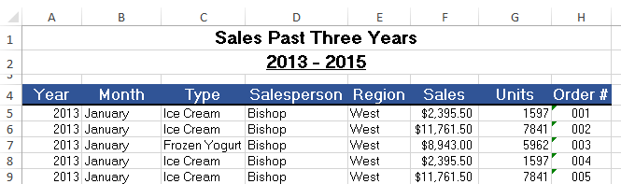

Creating Pivot table and charts 1:

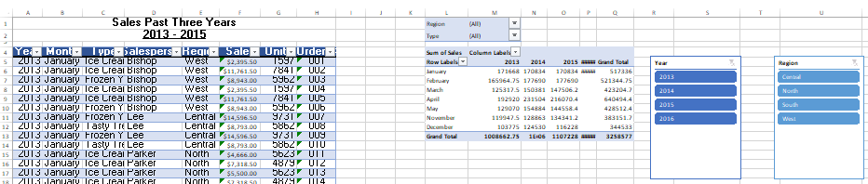

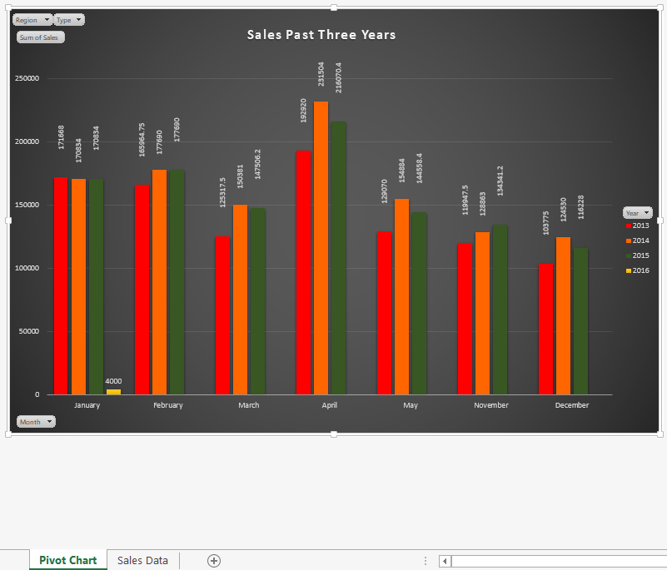

Pivot Table 2:

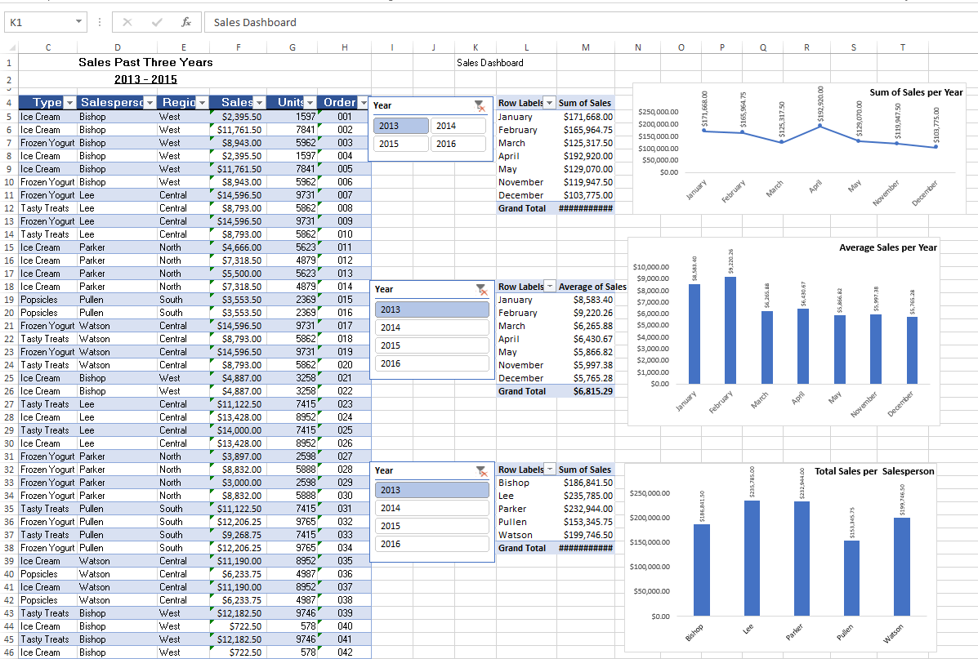

Pivot Chart 2
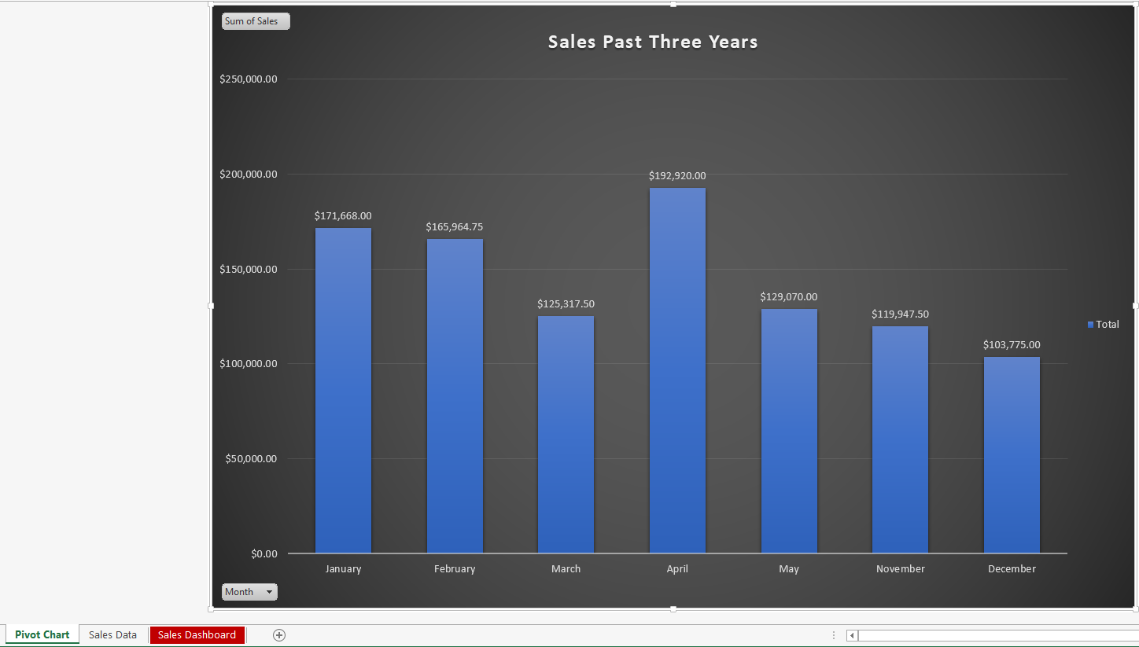

Creating a Dashboard in Excel:

